Homework 1
Signal and System

Q1) Determine the power of the following signals

(a) 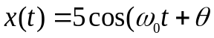
( b)
( c)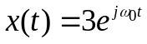

Q2) Determine the energy of the following signal

(a) 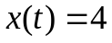
(b) 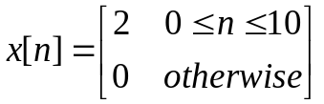

Q3) Find the fundamental period and fundamental frequency of the following signals

(a)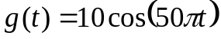
(b)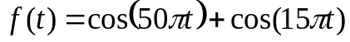
(c)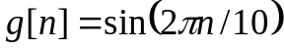
(d)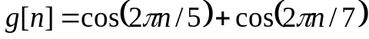
(f) 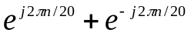

Q4) Determine whether the following systems are (1) memoryless (2) time-invariant (3)
(3) linear (4) Causal or BIBO . Justify your answers.

a)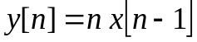
b)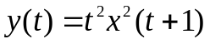
c)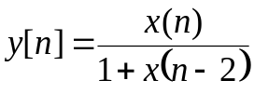
d)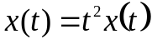

Q5) Determine whether the following system are Linear time invariant (LTI)

a)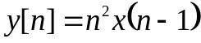
b)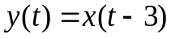
c)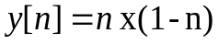
Note: The system consider (LTI) if satisfied two conditions linearity and time-invariant)

